CS609 Web Search Engine Final Report

Author: Zhiqian Yu, Peiying Deng, Chao Xi

## 1. Motivation

Nowadays, people all are interested in finding information like news that they need on the Internet and there are kinds of methods for locating it on different web pages. However, how to find the most related pages with information correlated the keywords they are searching for maybe is still cumbersome and time-consuming. For example, if someone wants to find the news with keyword “women” and “labor” from CNN news home page, so how can we immediately locate the web pages with related news from thousands of sub-pages and links begin with “http://www.cnn.com/”. Moreover, even if we find the webs with keywords in the news, how to represent these webs’ links to users clearly and succinctly is a problem as well. Although in some web pages, they offer us a simple search engine to select sub-links with related information, almost of results selected by their engine are not very accurate and clear. What’s worse, the fields these search engines can research are extremely limited, they can only give keywords related to pages’ links within this website’s filed. This inspire us to build a more intelligent, powerful and flexible search engine which will try to represent the related web links based on keywords and random web pages the users would like.

Then let’s talk about - what is Web Search Engine? A Web Search Engine is a software system that is designed to search for information on the World Wide Web. The search results are generally presented in a line of results often referred to as search engine results pages (SERPs). The information may be a mix of web pages, images, and other types of files. Some search engines also mine data available in databases or open directories. Unlike web directories, which are maintained only by human editors, search engines also maintain real-time information by running an algorithm on a web crawler.

There are three parts in whole process of web search engine work. The first part is web crawling, the second one is indexing and the third one is searching. A web search engine works by storing information in many web pages, which it retrieves from the HTML markup of the pages. A Web crawler - an automated web spider that follows every link on the site - retrieves these pages. The search engine then analyzes the contents of each page to determine how it should be indexed. For example, words can be extracted from the titles, page content, or headings. Data about web pages are stored in an index database for use in later queries. A query from a user can be a single word or a composition of words. The index helps find information relating to the query as quickly as possible. When a user inputs a query into the search engine, typically by using keywords, the engine examines its index and provides a listing of best-matching web pages according to its criteria, usually with a short summary containing the document's title and sometimes parts of the text. The index is built from the information stored with the data and the method by which the information is indexed. Most search engines support the use of the Boolean operators AND, OR and NOT to further specify the search query. Boolean operators are for literal searches that allow the user to refine and extend the terms of the search. The engine looks for the words or phrases exactly as entered. The usefulness of a search engine depends on the relevance of the result set it gives back. While there may be millions of web pages that include a particular word or phrase, some pages may be more relevant, popular, or authoritative than others. Most search engines employ methods to rank the results to provide the "best" results first. How a search engine decides which pages are the best matches, and what order the results should be shown in, varies widely from one engine to another. The methods also change over time as Internet usage changes and new techniques evolve. There are two main types of search engine that have evolved: one is a system of predefined and hierarchically ordered keywords that humans have programmed extensively. The other is a system that generates an "inverted index" by analyzing texts it locates.

In this project, we build a CGI-based web search engine with a friendly user search web interface, which users can input the URL location of web page and its sub-links may contain the information or news they interested in, in brief, the input page is the start page the search engine begin its search. Users can also input the number of links and keywords they want to search. Two types of searching results will be provided. The first one is Boolean query result and the second one is Vector query result. And both results represent in ranked.

In this report, there are seven sections. This section explains specific problems that we target on and gives a brief introduction to our project.

The rest of this paper is organized as follows. Section 2 is scenario; we offer examples that our project able to realize. Section 3 is all solutions we used and implemented in the project. Section 4 indicates and introduces some related analytics relevant to our work. Section 5 is future work, which may help improve accuracy and efficiency of the project. Section 6 is the workload by each member and Section 7 is reference.

## 2. The Scenario

Consider the following situations:

First, one wants to find something about 2016 United State presidential election and major candidate Hillary Rodham Clinton from US largest news website CNN.com. What will he or she do? A general process to find what a user is interested in contains three steps: Go to the CNN.com, Scan all the topic and find the one which is most likely what he wants, Scan the list of topics and find those about 2016 United State presidential election. Think about the process. It will take a lot of time for a user to find a certain topic from a website where the information definitely exists.

Second, when the programmers met some difficulties in their project, they also rely on the Internet. For example, if you find some bug in Java, you will put your error information in Google to get the solution. What Google returns to you is a great deal of links that might contain the information you give. But whether what the URLs links to is your solution? In most cases, it is not. It just gives some information related to your error, instead of the solution to the error. And the answer, in general, might be found in the web page links. For example, Google redirects you to stackoverflow.com. You can certainly know that there are solutions to the error you have met. The problem is how can you get to it.

What we have described above is two simple cases that a user of World Wide Web will meet everyday. The World Wide Web contains tons of information. For a given query, most of the information is useless. Our goal here is to reduce the time that a user will spend to find the web page that he or she is interested in. With our web search engine, users can get to the web page faster.

For situation one, what the user should do is just type the CNN.com and Key word to our web search engine, it will return all the possible web pages in the website in the order. The results that our web search engine returns will be ranked according to their relevance to the user’s topic. And for a given query, links return by the web search engine will not be too many. In general, you can find what you need from top ten results. It will save the user’s searching time.

For another situation, our web search engine can use the results from Google and give more specific web pages to the users in an efficient way. It will save a lot time for programmer, since debugging is always time consuming.

## 3. Solution

In order to reduce the time that users spend in searching on the Internet, one should consider three main problems.

First, how can you get the content of a certain web page, which you use to decide if it is the web page you are looking for or interesting in. It requires the system to recognize the key words or terms in the web page. What is more, if you do not find the content in this web page, the system should be able to transverse to another web page. It requires the system to find the relative URLs in the given web page and transverse to another web page by using the URLs.

Second, even though the system can get to the right web page that contains the topic you are looking for, how can you make the system to represent the content in a web page, since the content of a web page is massive and contain a lot of useless information such as some advertisement. It requires the system to represent the content of a web page in an efficient and correct way.

Finally, given that the system can find the right web page and present it in efficient way, how can you know which web pages is the most relative ones. There might be several web pages that contain the content you are interested in, but among them, there might be one or more pages that contain the exact topic you are looking for. It requires the system to rank those pages by the relativeness to you topic.

In this report, we propose three solutions to above problems: The web spider, Indexing of the web page and the searching engine.

### 3.1 Web Spider

A web spider or web crawler is an Internet bot which can systematically browses the World Wide Web and get the content of the web page it has transverse by given a root URL. A web spider can be used to solve the problem mentioned above(First problem). Therefore, there are two main problems in implementing the web spider.

In our project, we choose to use Python to build the web spider. We mainly use two packages in python: Request and Pyquery. We use Request to get whole content of a specific web page and traverse to its children’s pages. We use Pyquery to get the information we want to store on each web page the Request gets.

These two packages are provided by python. And they just provide us some useful function of dealing with URLs. (For the two packages, we must specify that we just use the function in the packages, but we do not use any source codes on the Internet.)

For the Request package, we get it from the URL <http://docs.python-requests.org/en/latest/>. We mainly use one function from this package which is called “get()”. With this function, we can get the source codes of a web page.

For the Pyquery package, we get it from the URL <https://pypi.python.org/pypi/pyquery>. We mainly use this package to filter out the information we need from the source code of a web page, which we get from the request.get() function. In our project, we use the package to get the links in a web page and the content we need to represent the web page.

Then, we need to deal with the information we get from the two packages. Consider the following situations:

First, there will be several duplicates in the World Wide Web. We can represent the web pages that a web spider will go through by using figure 3.1

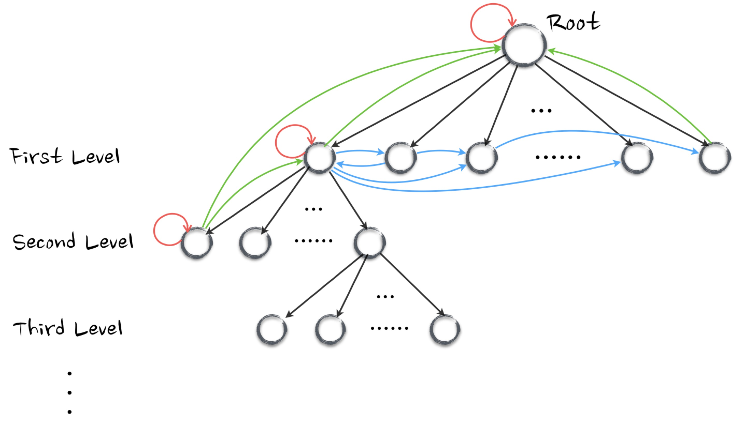

*FIGURE 3.1 THE STRUCTURE OF THE WORLD WIDE WEB*

The black circles represent the web pages in the World Wide Web. There is a root web page that you should give to the web spider, and each web page contains URLs that links to other web pages. From a root node, we can get several pages that the root links to, such as the black lines in the picture. Also, the nodes in each level have its own children in the next level. And each node in every level can have links to its brothers, as shown by the directed blue lines in the picture. What is more, all nodes except the root may have links to their ancestors, as shown by the directed green line in the picture. Finally, each node might have links to itself, as shown by the directed red line in the picture.

Since we can not retrieve same page more than once, we have to eliminate the blue lines, green lines and red lines in the picture.

Considering the format of HTML language, you can easily notice that the directed red lines only can be expressed by a URL that contains “#”; the directed green lines only can be expressed by a URL that contains “../” or “../../”, which represent “return to the upper level” and “return to the root” respectively. Therefore, we can easily eliminate those lines by checking if a URL contains those symbols.

However, there is not any symbol in HTML that represents the directed blue lines. The syntax in HTML that is used to represent the directed blue lines is same as the syntax that is used to represent the directed black lines. In our project, we use a structure name “set” to deal with the directed blue lines. We create a set named “found_list” which records the URLs that the web spider have already transverse. Then when a new URL comes in, we check if it is already in the set “found_list” first. If there is a record of the new URL in the “found_list”, we simply ignore it; otherwise, we can transverse to the web page by using the new URL and add it to the “found_list”. By using the set “found_list”, we can eliminate the directed blue lines.

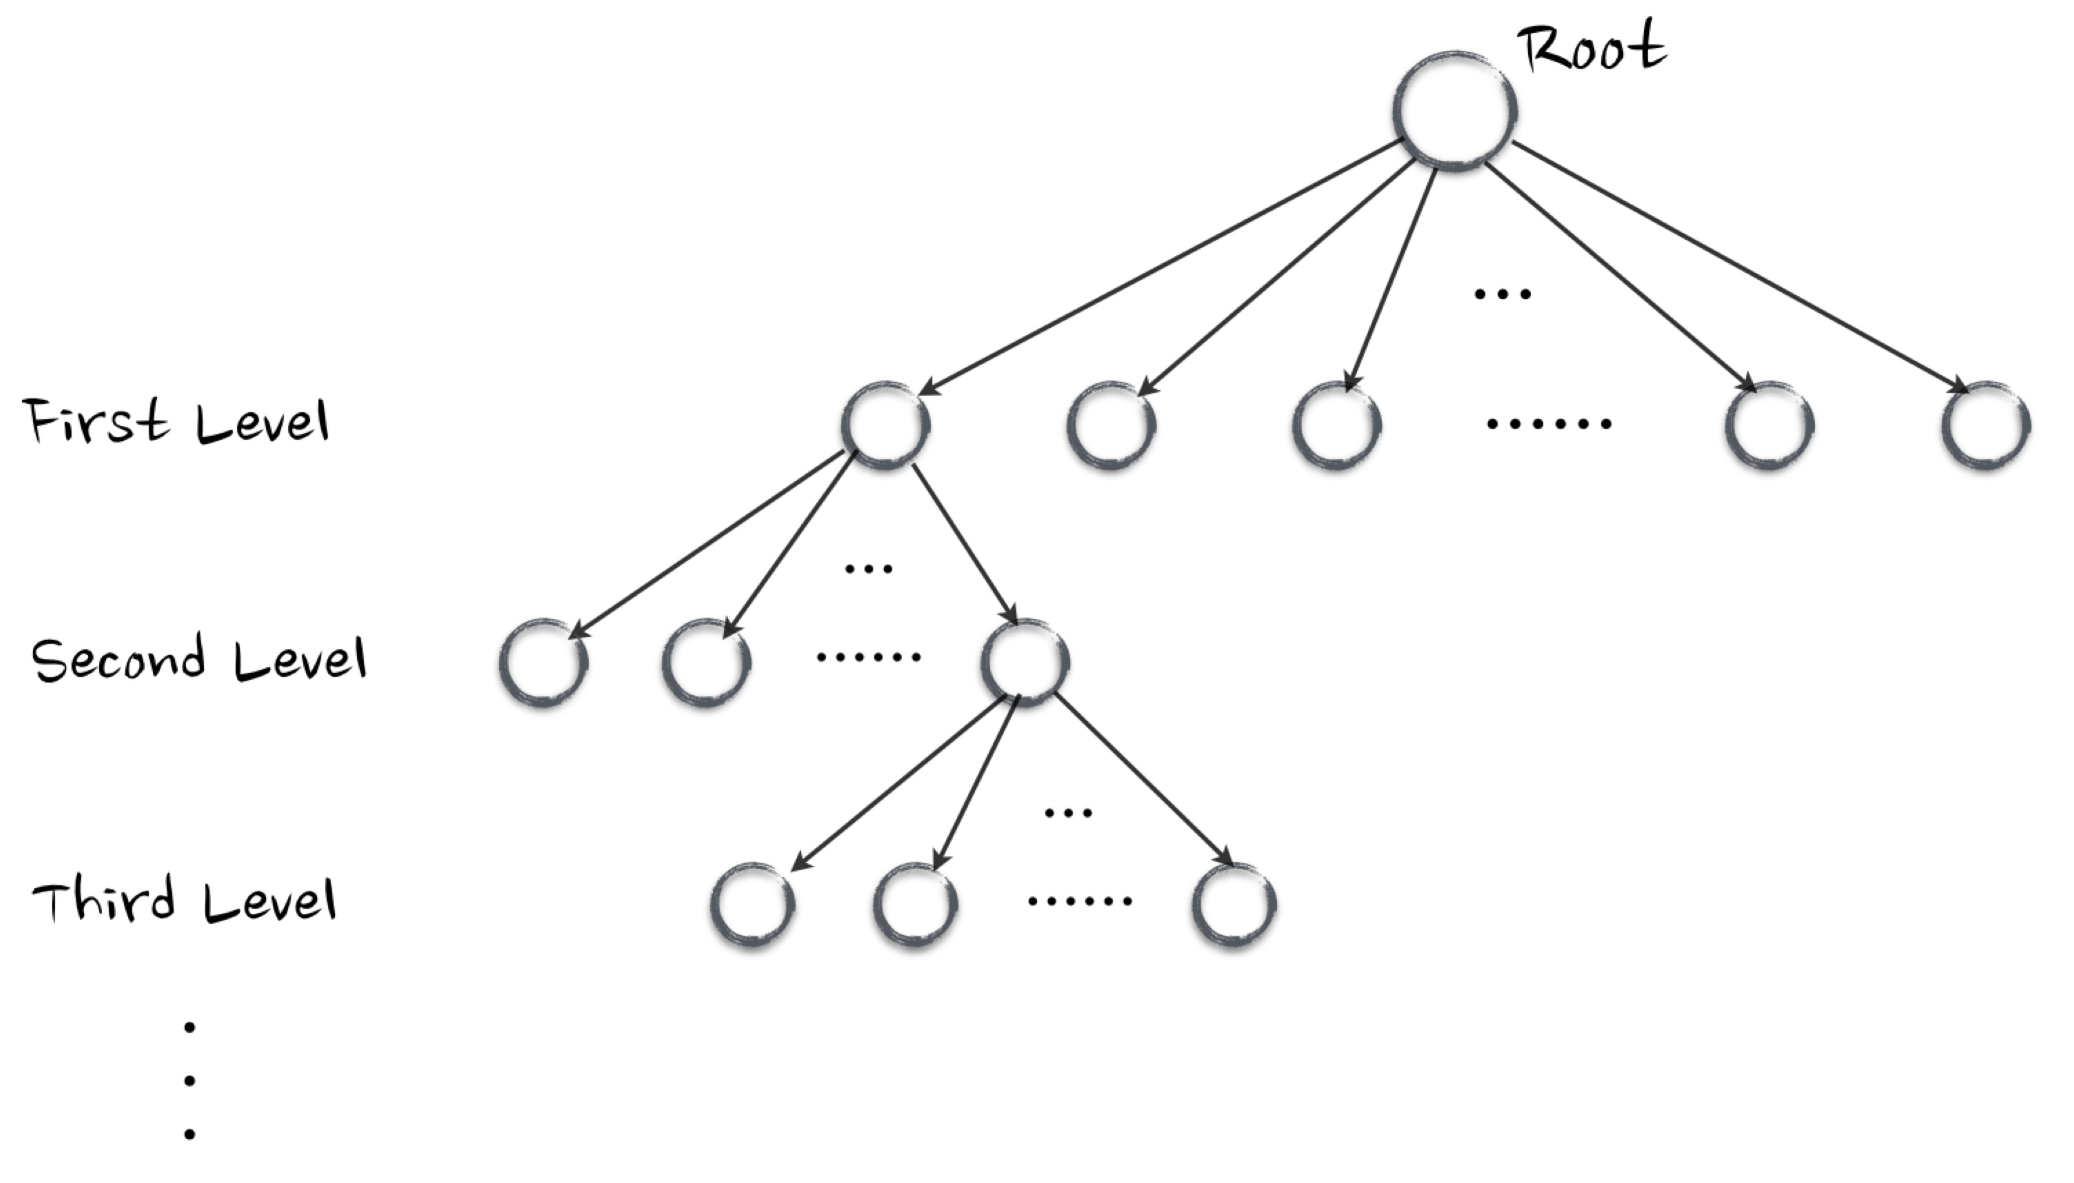

*FIGURE 3.2 THE STRUCTURE OF WORLD WIDE WEB WITHOUT DUPLICATE*

Second, which way should the web spider go without going back to the node that it have already transverse. Without the directed blue, green and red lines, figure 3.2 looks like a tree. Therefore, the problem becomes how can the web spider go through the tree. In our project, we choose to use Breadth-first search algorithm, since we think we should give more weights to the nodes that close to root. However, the height of the tree will be infinite, since we have collected all URLs in one web page without duplicates. Thus, it requires a condition where the BFS should stop. In our project, we define a limitation called “step”, which represents the number of web pages you want the web spider to retrieve. For example, if one set the “step” to 100, the web spider will retrieve 100 web pages before it stops. It dose not mean that the web spider will only go through 100 web pages, since there are duplicates in the web pages. In our experiment, we set the “step” to 50, but the number of web pages that the web spider has transverse is 141. The experiment result is shown in figure 3.2.

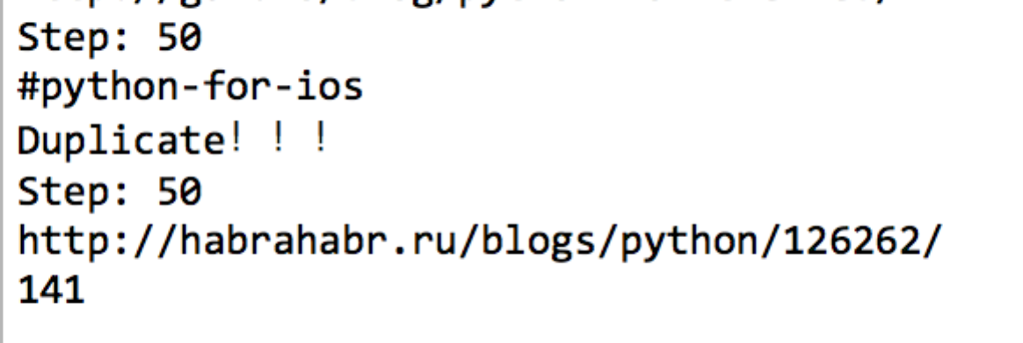

*FIGURE 3.3 THE RESULT OF “STEP” EXPERIMENT*

Finally, as we have mentioned above, the content of a web page is massive. We can get the source code from the web page, but which part of the source code is useful for us.

In our project, we have conducted several experiments to find out the useful information. We try to extra each of the symbol of HTML, such as “<title>”, “<ul>” or “<form>” etc. Then we compare the information we have extracted with the web page on the Internet, in order to find out what information is missing and what information is redundant. After those experiments, we find that the combination of “<title>”, “<p>” and “<a>” contains the most valuable information we need, even though there might be some duplicates. Therefore, in our project, we choose to retrieve the content of symbols “<title>”, “<p>” and “<a>” as the content of a certain web pages.

After three steps above, the result of the web spider is shown in figure 3.3 and figure 3.4.

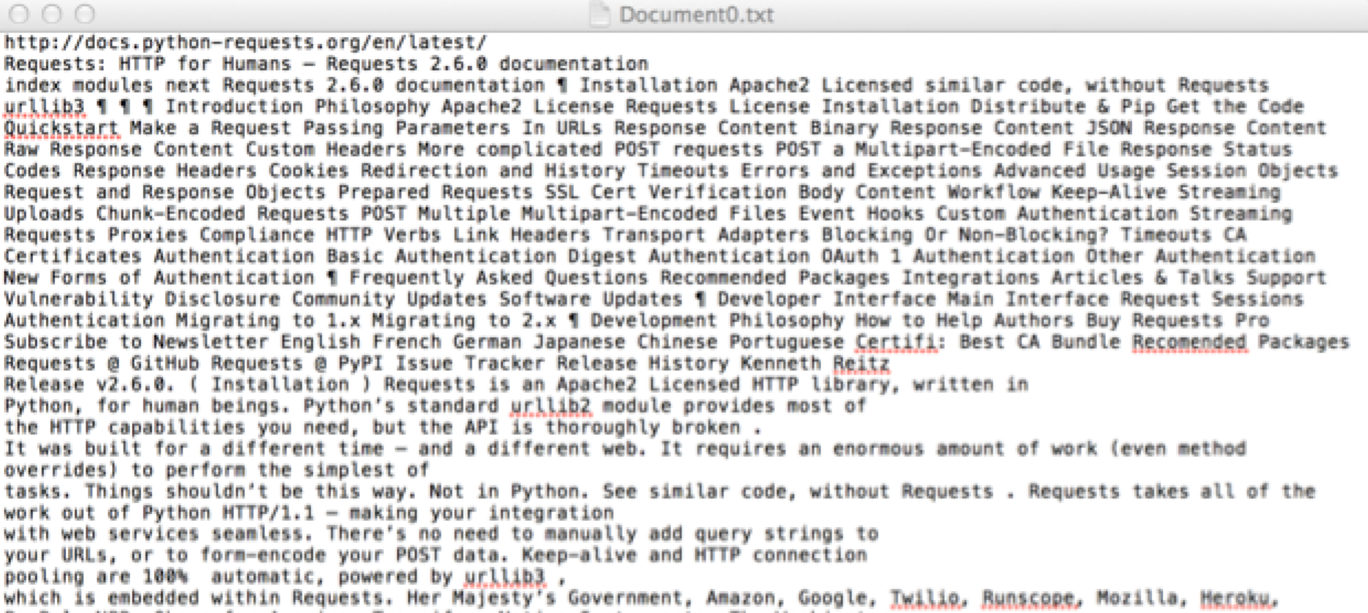

*FIGURE 3.4 THE CONTENT OF A CERTAIN WEB PAGE*

The figure 3.3 is a result of a certain web page. The “Document0.txt” indicate that it is the first web page that the web spider have transverse. The first line in the file indicates the URL of the web page. The rest of it is the valuable information that the web spider retrieved from the web page.

The figure 3.4 is a list of documents that the web spider has retrieved. The number of documents is set by users, which is represented by the stopping condition “step”.



*FIGURE 3.5 A LIST OF RETRIEVED DOCUMENTS*

Within a document collection, we assume that each document has a unique serial number, known as the document identifier (doc ID). During crawling, we can simply assign successive integers to each new document when it is first encountered.

Since there are some links that will contain some videos, it will take a lot of time of the web spider to get the content of those types of web page. And the content of the web page will be empty. Thus, I add one more limitation to the web spider—when a URL response time exceeds 1 second, the web spider will ignore it.

### 3.2 Inverted Index

The inverted index data structure is a central component of a typical search engine’s indexing algorithm. A goal of a search engine implementation is to optimize the speed of the query: find the documents where word X occurs.

There are two basic assumptions for inverted index:

* Optimize for retrieval.
* Searching should be fast, since users are usually impatient.
* Indexing speed isn't critical.
* Document collection is assumed relatively stable for the moment.
* But for our search engine, we combine crawling, indexing and searching together, so the indexing becomes an online-process. Thus the indexing speed is critical as well.

To gain the speed benefits of indexing at retrieval time, we have to build the index in advance. The inverted index consists of term list and postings list. The major steps in this are:

*Step 1*: Map each document number to its link (the first line in Figure 3.3) as shown in Figure 3.5, for us to implement search algorithms later.

*Step 2*: From Figure 3.3 we can see that, the raw content of documents retrieved from web is in a mess and complicated, and the scrollbar on the right shows each document has a large quantity of information. A huge amount of preprocessing needs to be done first, for easily extracting terms and storing meaningful information well. Lots of punctuations and symbols need to be filtered. Meanwhile keep some fixed format like “v2.6.0”, “home-sick”, “20%” etc.

*Step 3*: Tokenize the text, turning each retrieved document into a list of terms. After the preprocessing, basically we just split a string by space. And we eliminate stop-words while doing the splitting. Removing them helps to improve index efficiency a lot.

*Step 4*: Stem the terms. Some terms such as “apple” and “apples” should be considered as one term; “watch” “watches” “watching” “watched” should be combined as one term. Stemmer should be applied in order to improve Index and Search efficiency.

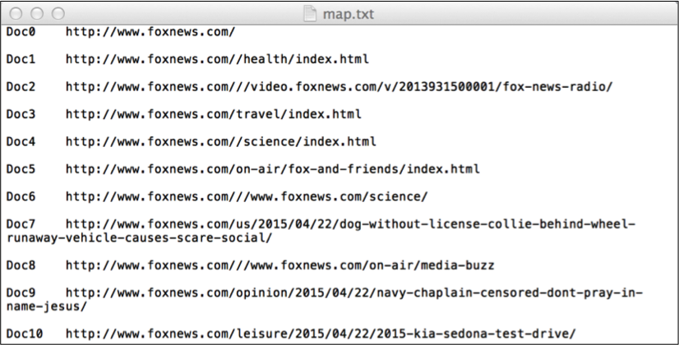

Figure 3.6: Mapping Doc Number to Link

*Step 5*: After all documents have been processed, write the inverted index to disk. Based on two types of retrieval strategy we choose, we create 2 different inverted indexes respectively, and what goes in the postings is presented as follows. For Boolean retrieval, just the document number; for Ranked (Vector Space) retrieval, document number and frequency the term appears in the document (tf).

|  |  |
| --- | --- |
|  |  |

Figure 3.7: Index Examples for Boolean(left) and Vector(right)

The format of index for Boolean Model is:

<term> [doc#, doc#, …, doc#]

The format of index for Vector Space Model is:

<term> [(doc#, frequency the term appears in the doc), …, (…)]

The data structure we use for the whole index is dictionary, and for a posting list is list in Python. Dictionaries are indexed by keys, which can be any immutable type, and in our case, is exactly the term. List, as the value of dictionary, is a very flexible, variable-length and randomly accessible object, also the most versatile data type in Python. Dictionaries provide fast lookups, based on keys, to get values, which is exactly what we need.

The input to indexing is a list of normalized tokens for each document, which we can equally think of as a list of pairs of term and doc#. Since a term generally occurs in a number of documents, this data organization already reduces the storage requirements of the index. The tf information is not vital for a basic Boolean search engine, but it allows us to improve the efficiency of the search engine at query time, and it is a statistic later used in many ranked retrieval models.

Moreover, the indexing is sorted alphabetically. The good thing of this is that, if we have a long list to find the, we can apply optimized search algorithms like binary search to improve efficiency. This inverted index structure is essentially without rivals as the most efficient structure for supporting ad hoc text search.

### 3.3 Search Engine

By web spider and indexing, we can get a list of documents and an efficient representation of those documents. Thus, it is the time for the system to find out the documents that are related to a user’s topic or query.

In our project, we implement two algorithms to filter out relative documents: Boolean and Vector Space. Both of them provide ranking function.

### 3.3.1 Boolean Query

A Boolean query is a query that matches documents matching Boolean combinations of other queries. Boolean logic is a system of showing relationships between sets by using the words "AND", "OR", and "NOT".

First of all, since we have the terms stemmed, the query should be stemmed as well.

For arbitrary Boolean queries, we have to evaluate and temporarily store the answers for intermediate expressions in a complex expression. However, in many circumstances, either because of the nature of the query language, or just because this is the most common type of query that users submit, a query is purely conjunctive.

Boolean operators are too rigid. Natural language is more complicated than those Boolean operators. At first we have stored position information for each term in our first indexing version, but then we realize that proximity operators are relatively easy to implement, but less efficient. We omit this solution to maintain the efficiency.

An additional big problem is, finding the right number of hits can be tricky. Boolean queries often result in either too few (=0) or too many (1000s) results. Sometimes search tools will bring up thousands of hits, when all that is needed is one. Sometimes only a couple of hits emerge from a search when you need as many as possible. Sometimes you want just enough for a good two, ten or twenty page paper. How many is that? It depends on the context and on the quality or relevance of the hits. Chances are you will only use a fraction of the hits that emerge from a single search. In this sense, more is better.

Thus we did the ranking in Boolean retrieval based on as follows:

－ Query for the first set is the AND of all the terms

－ Then all but the first term, all but the second term, …

－ Then all but the first two terms, …

－ And so on until each single term query is tried.

Implementation of this with three and more terms is not easy. For instance, for in total 4 terms, we need to calculate for as in Figure 3.8.

Figure 3.8: Example of Calculating Boolean Ranking Results

· rank1 = {X1∧X2∧X3∧X4}

· rank2 = ({X1∨X2∨X3∨X4}–{X1}) ∨ ({X1∨X2∨X3∨X4}–{X2}) ∨ … – rank1

· rank3 = ({X1∨X2∨X3∨X4}–{X1∨X2}) ∨ ({X1∨X2∨X3∨X4}–{ X2∨X3}) ∨ … – rank1– rank2

…….

Figure 3.9: Alternative of Calculating Boolean Ranking Results

· rank1 = {X1∧X2∧X3∧X4}

· rank2 = {X1∧X2∧X3} ∨ {X2∧X3∧X4} ∨ {X2∧X3∧X4} – rank1

· rank3 = {X1∧X2} ∨ {X2∧X3} ∨ {X3∧X4} ∨ {X1∧X3} ∨ {X2∧X4} ∨ {X1∧X4} – rank1 – rank2

· rank4 = {X1} ∨ {X2} ∨ {X3} ∨ {X4} – rank1 – rank2 – rank3

Final results = rank1 + rank2 + rank3 + rank4, in which rank1 is the most satisfying result, then rank2, then rank3…

We can see that there will be tremendous amount of operations, and if we don’t know the exact number of terms, it will be hard to write specific code. Instead, we use an integrated method from a Python package itertools.combinations, to combine the doc lists of terms first.

E.g., for a group of 4 doc_lists = ['1', '2', '3', '4'] we will get the combination lists group:

[('1', '2', '3', '4'), ('1', '2', '3'), ('1', '2', '4'), ('1', '3', '4'), ('2', '3', '4'), ('1', '2'), ('1', '3'), ('1', '4'), ('2', '3'), ('2', '4'), ('3', '4'), ('1',), ('2',), ('3',), ('4',)]

Hence we can easily get non-duplicate results using set, from these combine lists. Now we simplify the intersection, union and subtract as shown in Figure 3.9.

Our Boolean query takes a more-matches-is-better approach. It seems reasonable.

However, the weaknesses of Boolean vector model are very obvious.

Although we use ranked retrieval to order documents by how likely they are to be relevant to the information need, solving the inflexible problem, retrieval based on binary decision criteria (with no partial match) does not reflect our intuitions behind relevance adequately. To fix this, we can try a similarity-based query, as discussed in Section 3.3.2.

#### 3.3.2 Vector Space Algorithm

Before getting to the certain algorithm, focus on the index of vector space which is the right part of figure 3.6. Unlike the inverted index of vector space algorithm which should contain the TF and IDF, the inverted index for vector space algorithm in our project records the frequency of each term that appears in each document. The reason why we do not compute the IDF directly is that we need to compute the length of each document to normalize the product of TF and IDF.

Thus, in order to get the normalized TF, IDF for each term and each document, we should get: the IDF for each term, the frequency of each term in each document and the length of each document.

(1) Calculate the IDF for each term

IDF, which is inverse document frequency, represent how important a term is. It can be calculated by the following formula:

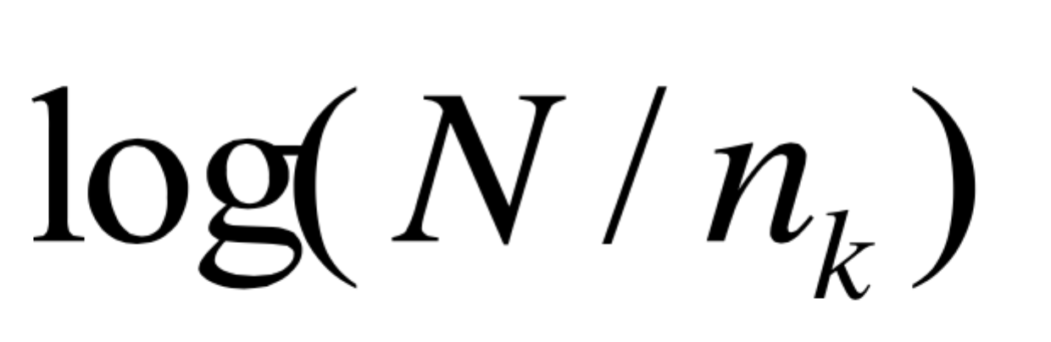

Where the N represents total number of documents in the collection C, nk represents the number of documents in C that contain term k.

In our project, we can calculate the IDF for each term directly by using the index generated in right part of figure 3.6. The N in our project equals to the “step” which is set by users. The nk in our project equals to the number of document in each term, which can be calculated by using vector space index.

Take the term “london” in the vector space index. According to the index, there are three documents that contain term “london”. Term “london” appears two times in Document3, three times in Document4 and one time in Document7. Assuming that users set the “step” to 30, then the IDF of term “london” equals to log(30/3), which is 1.

Following the above steps, we can get all IDFs for each term.

(2) Calculate the frequency of each term in each document

TF, which is term frequency, represent how frequent a term is. The TF records the frequency of each term in a specific document. In our project, we can get the TF for each term in each document from the vector space index directly.

Using the same example, for term “london”, we get the TF of document3 is 2, TF of document3 is 3, TF of document7 is 1 and TF of rest of documents are all 0.

(3) Calculate the length of each document.

The length of a document, which is represented by a vector, can be computed by using following formula:

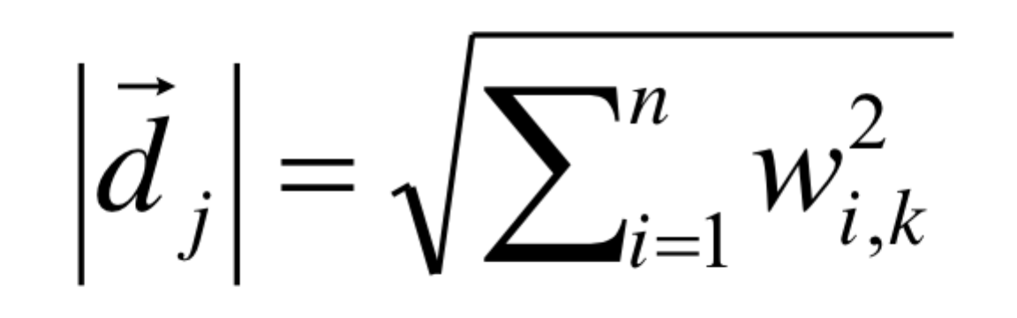

where dj represents a vector of a document, wi,k represents the weight of each term in the document.

The weight of each term in a document can be calculate by following formula:



where tfik represents the frequency of term k in document I; idfk represents the IDF of term k.

Since we have already calculated all TF and IDF, it is easy to get the weight of each term in each document.

However, it is the most difficult part of implementing the vector space algorithm. The vector space index is created by using term vectors, but in order to compute length of a document, we should represent the vector by using documents. That is, we have to create a list of vector by using documents.

In the project, we use a structure called “dictionary” to represent a list of vector by using documents. The algorithm to create such a dictionary is as follow:

Create a “dictionary” named vector_document.

First, for each term t in the vector space index which is created in section 3.2, find each document that contains term t and use the document number as the key of “vector_document”, and use the product of its frequency, which is TF of term t in the document, and the IDF of term t as the value of the “vector_document” with its document number as the key.

Second, as the iteration proceeds, check if the key of “vector_document” contains the document number in the iteration. If the key exists, just append the new value to the key; otherwise, create a new entry in the “vector_document” with this document as key and add the value to the key.

Third, repeat steps above until all terms have been processed.

Given this algorithm, we can get the list of vector by using document. But how about the efficiency of this algorithm?

If there are n terms in total and at most m documents that is in the term, the time complexity of the algorithm is O(n*m). It seems a lot, but notice that all of these process will be done in the main memory and the number of terms in total will not be too large. Thus, this algorithm will not affect the behavior of the search engine. In fact, up to 10,000 terms in total, it will only take about 0.01 second to get “vector_document”.

Once we can represent the document by the weight generated by the product of TF and IDF, we can easily compute the length of the document.

The result of this algorithm is shown in figure 3.10.

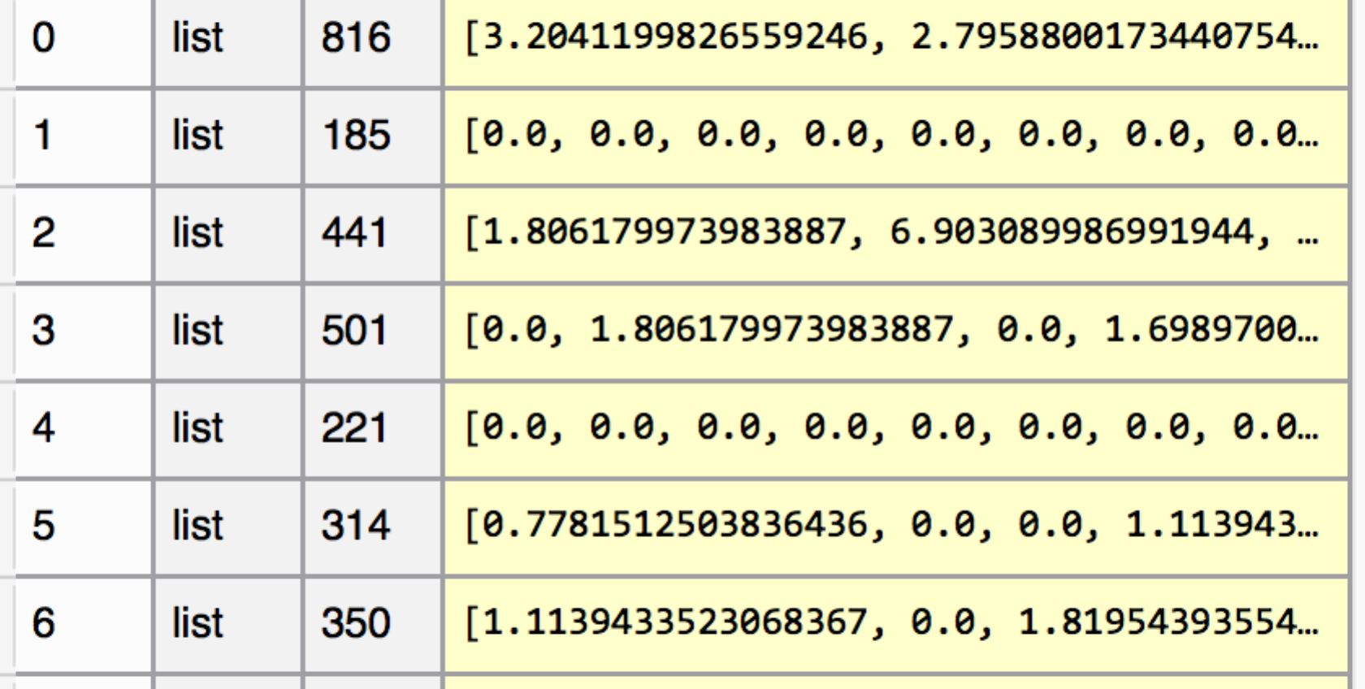

*FIGURE 3.10 THE RESULT OF FIND VECTOR_DOCUMENT ALGORITHM*

Then, when a query comes in, we should just multiply it with the normalized vector_document and rank the result. We can get the output of vector space algorithm.

### 3.4 Web Interface

Since python can easily combine with HTML language, we just use HTML to design our interface.

The basic frame of Web Search Engine (WSE) is shown in Figure 3.11. Through an interface we given, users request the search results from our WSE. And WSE returns HTML pages with search results on.

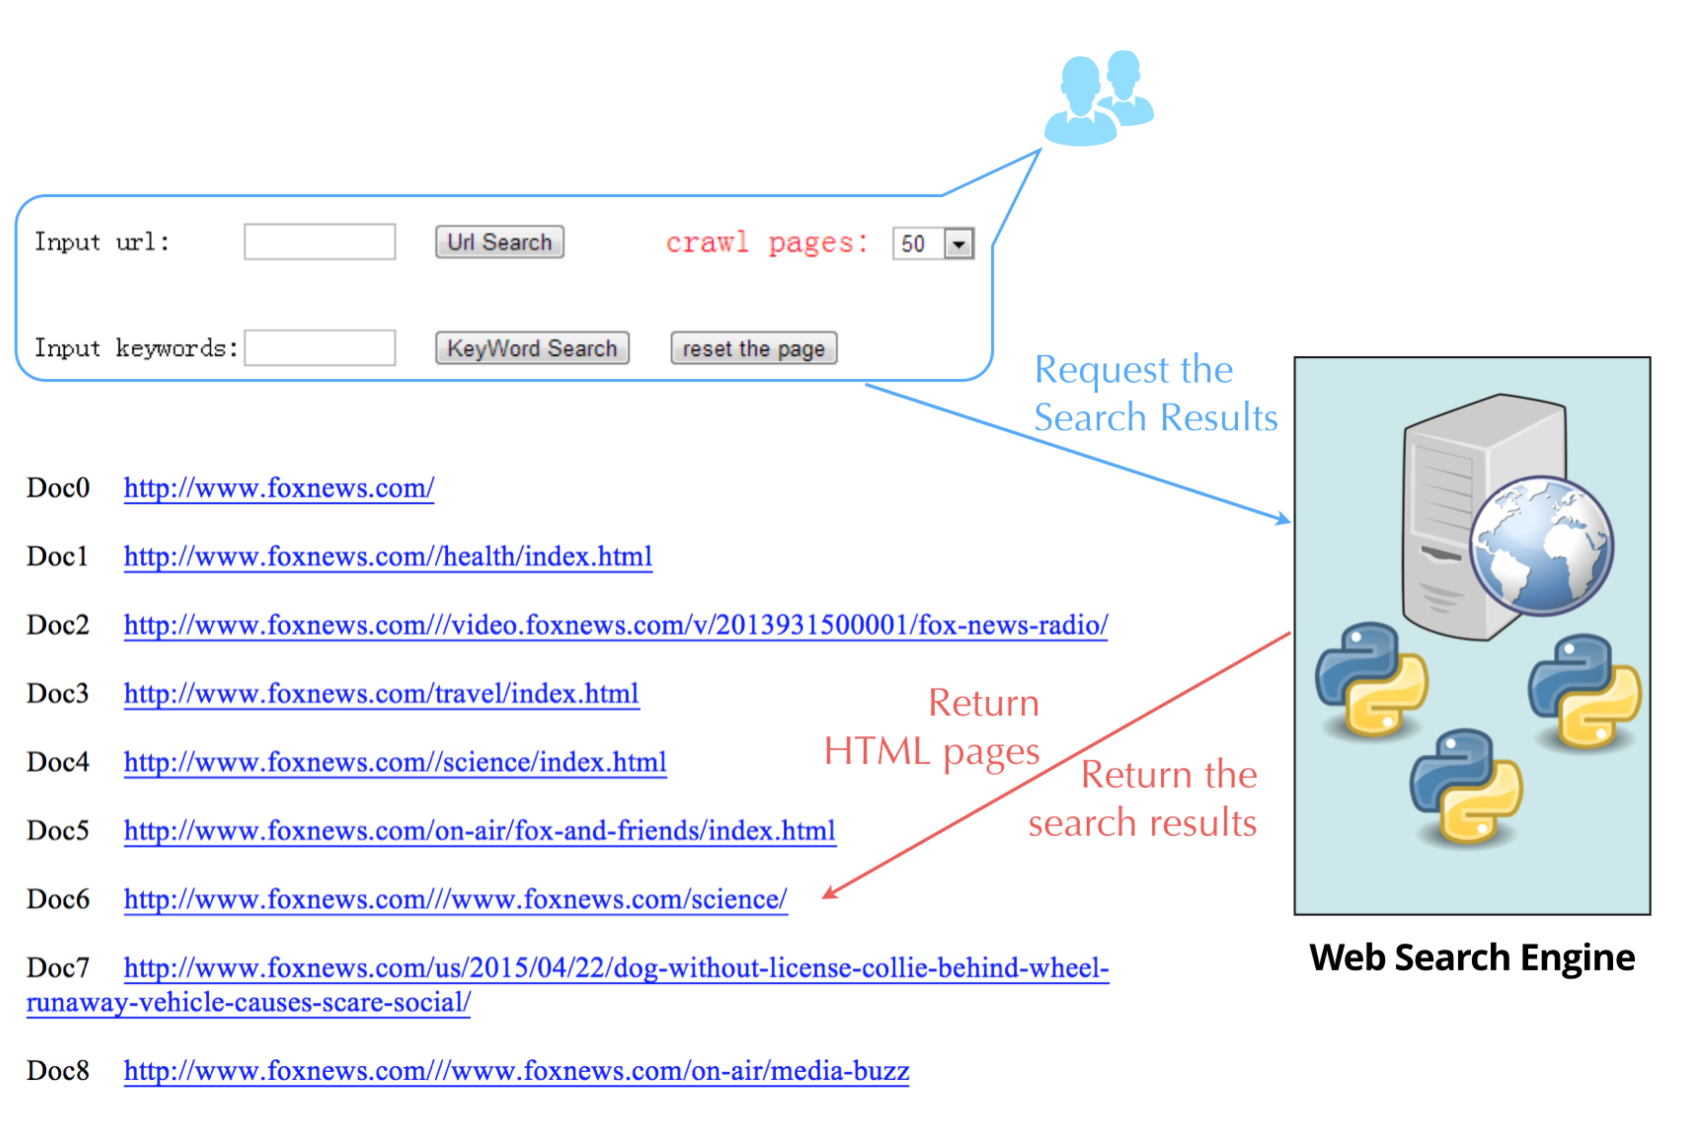

Figure 3.11: Basic Frame of WSE

We have tried several web servers, at last we choose Apache 2. Python + HTML/PHP + Apache is a classical CGI-based group.

We should call the web search engine programmed by Python from HTML page. So we need to run python program as Script on Web. The first thing is to configure Apache server to support Python run as CGI Script. The second thing is executing Python program from front search page, we need use HTML page to call .py program.

Figure 3.12 is the home page of our Web Search Engine.

The above search bar is used to input a random “http://” or “https://” URL that users want to crawl. That is the root URL that we would start with;

The below search bar is used to input the query users want to search from all the retrieved pages;

The Crawl Size on the right is the number of documents that users want the web spider to retrieve. That is, the end point of the BFS. We set 50 as the default value.

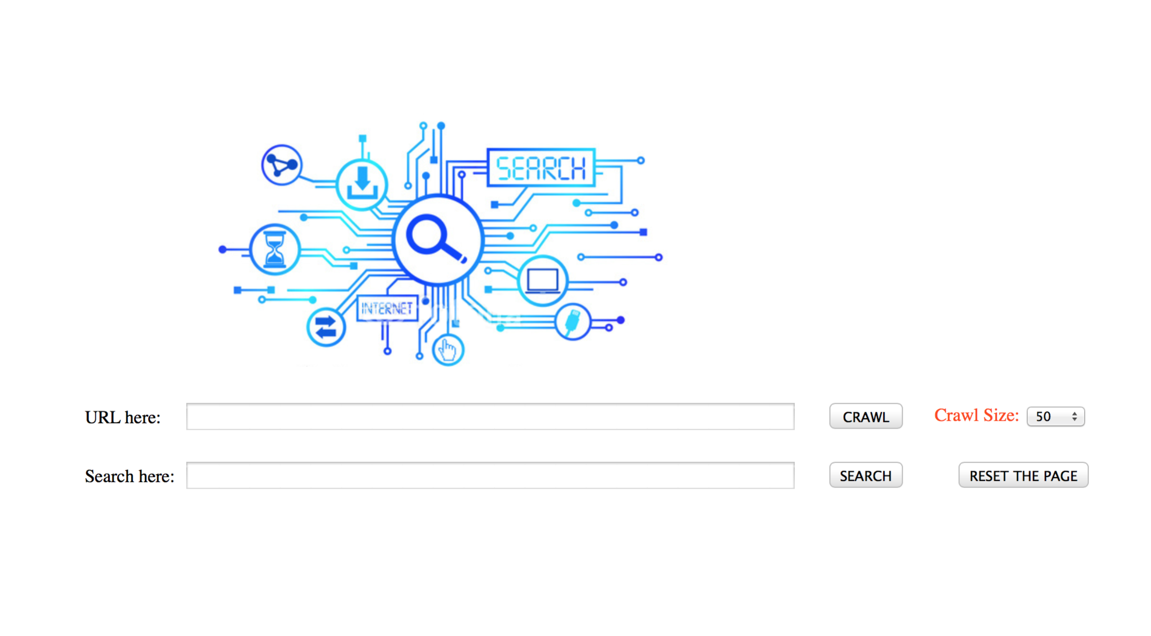

Figure 3.12: Home Page of WSE

We use cgi.FieldStorage().getvalue() to get values from the page.

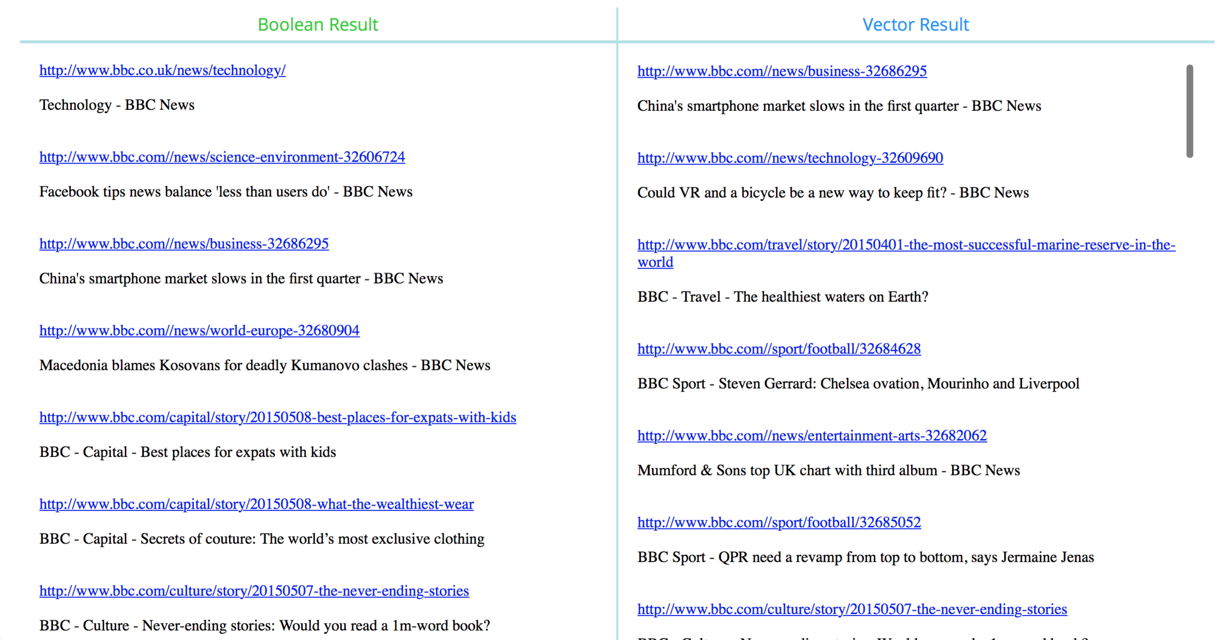In our example for showing the results, we use <http://www.bbc.com/> as start URL, query ‘march MARKET Marks ’ as an example query, and crawl size of 50. The result page is shown in Figure 3.13.

What’s interesting of our result page is that, users can compare two different query results at one screen at one time. The left column is the results for Boolean query, and

Figure 3.13: Result Page of WSE

the right is the results for Vector query. We can see that the ranking is very different. The 1st one in Boolean side actually is the 17th in the Vector side.

## 4. Related Work

A great many of analytical techniques have been proposed toward a better understanding of information retrieval model in web search engine. Below we briefly describe the work that is most relevant to the current work. It can be categorized into four parts, Crawling techniques, Inverted index, Boolean retrieval model and Vector space model.

**Crawling Techniques**. The web spider goes through several web pages from a root web page, which is given by users. Our web spider uses BFS as its searching algorithm, and needs a number called “step” that is set by users to stop. Also, our web spider will eliminate all duplicates URLs in one certain web page, including the URL links to its parent pages, the URL links to its brother pages and the URL link to itself. What is more, our web spider is set to ignore web pages whose response time is more than 1 second, since there are some URLs links to some videos or links to some advertisement. Finally, our web spider will record all the pages that it have transverse, and generate one document for each web page. In each document, our web spider will record the most useful information in the web page.

**Inverted Index**. Search engine indexing collects, parses, and stores data to facilitate fast and accurate information retrieval. Our search engine incorporates an inverted index when evaluating a search query to quickly locate documents containing the words in a query and then ranks these documents by relevance. The inverted index can be considered a form of a dictionary in this paper. And corresponding to two types of retrieval model, we have Boolean index and Vector index made.

**Boolean Retrieval Model**. The Boolean model may be called the first model of information retrieval and probably also the most criticized model. The model can be explained by thinking of a query term as an unambiguous definition of a set of documents.

Basically, one query term simply defines the set of all documents that are indexed with that term. Using the operators of George Boole’s mathematical logic, query terms and their corresponding sets of documents can be combined to form new sets of documents. Boole defined three basic operators, the logical product AND, the logical sum OR and the logical difference NOT. Combining terms with the AND operator will define a document set that is smaller than or equal to the document sets of any of the single terms, i.e. the intersection of both sets. Combining terms with the OR operator will define a document set that is bigger than or equal to the document sets of any of the single terms, i.e. the union of both sets.

As discussed in Section 3.3.1, three obvious weaknesses of Boolean Retrieval Model are rigid operators not compatible with natural language in reality; users want to find the right number of hits that Boolean queries usually can not satisfy by return either too few or too many results; retrieval based on binary decision criteria does not reflect our intuitions behind relevance adequately. The solution Boolean ranking model introduced in this report nearly fixes the first and the second problems. And the third will be optimized by the following retrieval analysis.

**Vector Space Retrieval Model**. It is an algebraic model for representing text documents as vectors of identifiers, such as, index terms. It is used in information filtering, information retrieval, indexing and relevancy rankings. Its first use was in the SMART Information Retrieval System. Documents and queries are represented as vectors.

Each dimension corresponds to a separate term. If a term occurs in the document, its value in the vector is non-zero. Several different ways of computing these values, also known as (term) weights, have been developed. One of the best-known schemes is TF-IDF weighting the definition of term depends on the application. We can get the normalized TF-IDF using the formulation below as a score for a term in each document and rank the document by it.

$w_{ik}= {tf}_{ik}*{idf}_{k}={tf}_{ik}*log\left(\frac{N}{n_{k}}\right)$ $length=\sqrt{\sum_{i=1}^{n}{{(w_{ik})}^{2}}}$

Typically terms are single words, keywords, or longer phrases. If words are chosen to be the terms, the dimensionality of the vector is the number of distinct words occurring in the corpus.

What’s worth mentioning is, as discussed in Section 3.4, users can compare two different query results at one screen at one time by our web search engine.

## 5. Future Work

There are certain some improvement can be done to improve our web search engine. We mainly conclude the improvement as two parts: the web spider and the search engine.

### 5.1 Improvement in web spider

First, the web spider is able to deal with 5XX and 4XX errors response by a web page, but in some web site, it has already dealt with those errors. They redirect an error page instead of returning an error. Thus, the web spider will retrieve those error pages repeatedly, since the URLs are different. The conditions should be more restrictively so that the web spider can not retrieve a certain page twice or more times.

Second, the content of a certain web page, which the web spider retrieved, contains some duplicates, since the syntax “<a>” will sometimes appears in the syntax “<p>”. This will affect the frequency of a certain term in a document. We should find more exactly standards to restrict the content that the web spider should retrieve.

### 5.2 Improvement in search engine

First, the TF information is not vital for a basic Boolean search engine, but it allows us to improve the efficiency of the search engine at query time, and it is a statistic later used in many ranked retrieval models. Actually we can implement the Boolean search and Vector search both using only the vec_index as shown on the right in Figure 3.3. However at first we just made some assumptions and split them into two parts for convenience. Given time, we can modify this and raise the indexing speed further.

Second, there are many meaningful words or punctuations that can’t be easily eliminated during the preprocessing. Likewise, there will be much meaningless information if I just keep some fixed form. How to build a parse tree out of them by recognizing their type and purpose is very difficult.

Finally, to keep it simple, we just eliminate all other languages’ terms except for English from the term list, including Chinese, Japanese and so on. There is not enough time in our schedule to study extracting terms from those languages that can’t be simply spilt like using space.

In addition, we should design our more carefully, so that it will be more friendly to users. For example, instead of showing the URLs and title of the web pages, we should highlight the matching content of the web pages just like what Google does.

**REFERENCE**

1. Jon Kleinberg, " Authoritative Sources in a Hyperlinked Environment", Proc. 9th ACM-SIAM Symposium on Discrete Algorithms, 1998. Extended version in Journal of the ACM 46(1999). Also appears as IBM Research Report RJ 10076, May 1997.
2. A. Ng, A. Zheng, and M. Jordan, "Link Analysis, Eigenvectors and Stability", IJCAI-01.
3. Falk Scholer Hugh E. Williams John Yiannis Justin Zobel, "Compression of Inverted Indexes For Fast Query Evaluation", SIGIR 02.
4. Hugh E. Williams, Justin Zobel Dirk Bahle, "Fast phrase querying with combined indexes", ACM Transactions on Information Systems (TOIS), 04.
5. Junghoo Cho, Hector Garcia-Molina and Lawrence Page, "Efficient Crawling Through URL Ordering", Stanford University, 1998.
6. E. Markatos, "On caching search engine query results", Computer Communications, 24 (7) (2000), pp. 137–143
7. Soumen Chakrabarti, Martin van den Berg and Byron Dom, "Focused Crawling: A New Approach To Topic-Specific Web Resource Discovery", Elsevier Science B.V., 1999.
8. Allan Heydon and Marc Najork, "Mercator: A Scalable, Extensible Web Crawler", WWW, 1999.
9. W.G. Waller, Donald H. Kraft, "A mathematical model of a weighted boolean retrieval system", Information Processing & Management Volume 15, Issue 5, 1979, Pages 235–245
10. Joon Ho Lee, Myoung Ho Kim, Yoon Joon Lee, "Ranking documents in thesaurus-based boolean retrieval systems ", Information Processing & Management, Volume 30, Issue 1, January–February 1994, Pages 79-91
11. Wen Zhanga, Taketoshi Yoshidab, Xijin Tangc, "A comparative study of TF*IDF, LSI and multi-words for text classification", Expert Systems with Applications Volume 38, Issue 3, March 2011, Pages 2758–2765
12. W.M. Shaw Jr, Robert Burgin, Patrick Howell, "Performance standards and evaluations in IR test collections: Vector-space and other retrieval models ", Information Processing & Management, Volume 33, Issue 1, January 1997, Pages 15-36
13. William R. Caid, Susan T. Dumais, Stephen I. Gallant, "Learned vector-space models for document retrieval ", Information Processing & Management, Volume 31, Issue 3, May–June 1995, Pages 419-429
14. Mauricio S. Oyarzun, Senen Gonzalez, Marcelo Mendoza, Flavio Ferrarotti, Max Chacon, Mauricio Marin, “A vector model for routing queries in web search engines”, Procedia Computer Science, Volume 1, Issue 1, May 2010, Pages 457-464